**Task 16: Relational Database Service**

Amazon RDS is a versatile and powerful managed database service that streamlines database management, enhances scalability and security, and supports multiple database engines, making it suitable for a wide range of applications and workloads.

**AWS RDS Setup and Integration**

1. Created an EC2 Instance named RDS

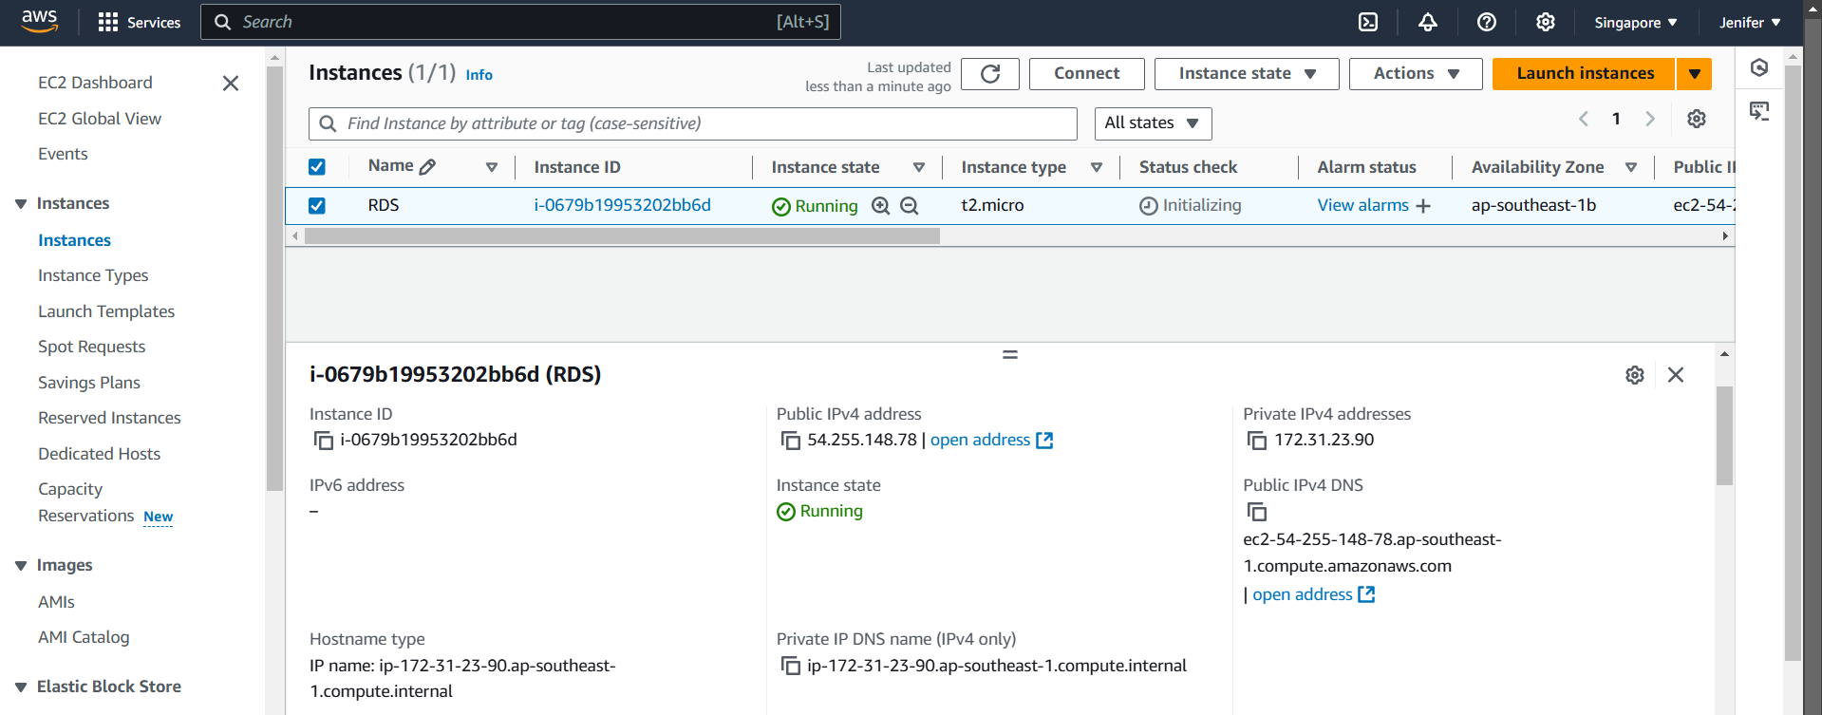

Subnet Groups are collections of subnets that you designate for your Amazon RDS instances in a specific Virtual Private Cloud (VPC).

1. Created Subnet Group for the Database

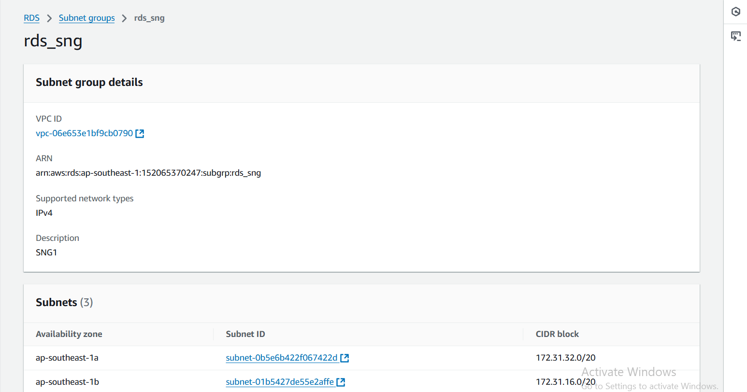

1. Created a Database with the MariaDB Engine

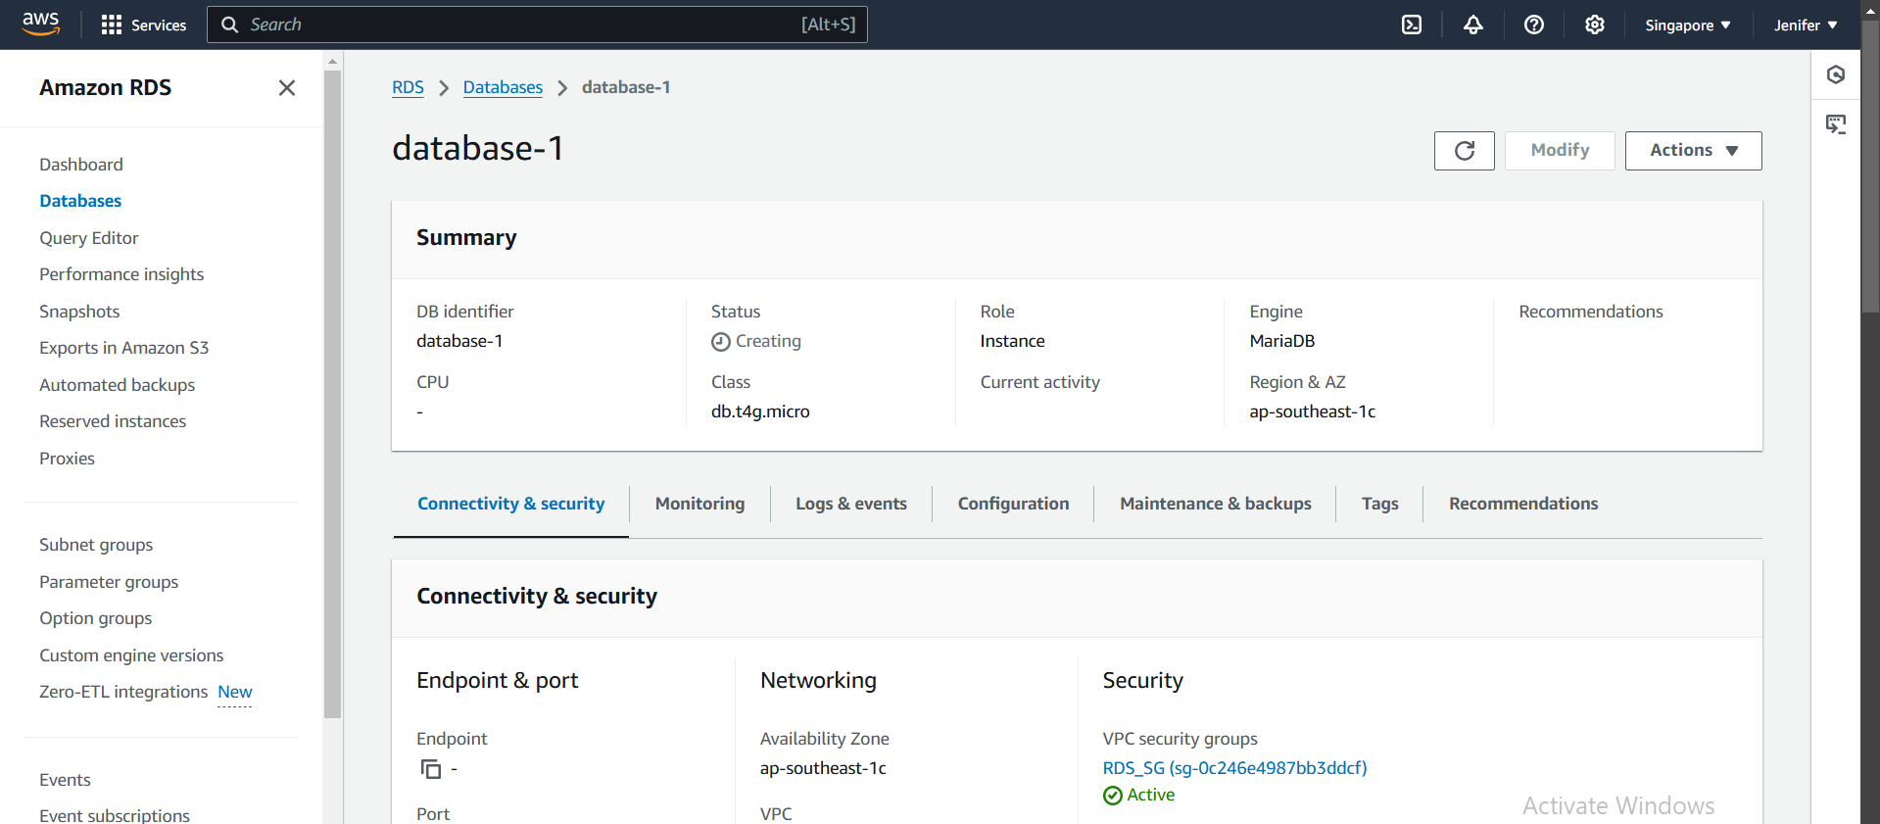

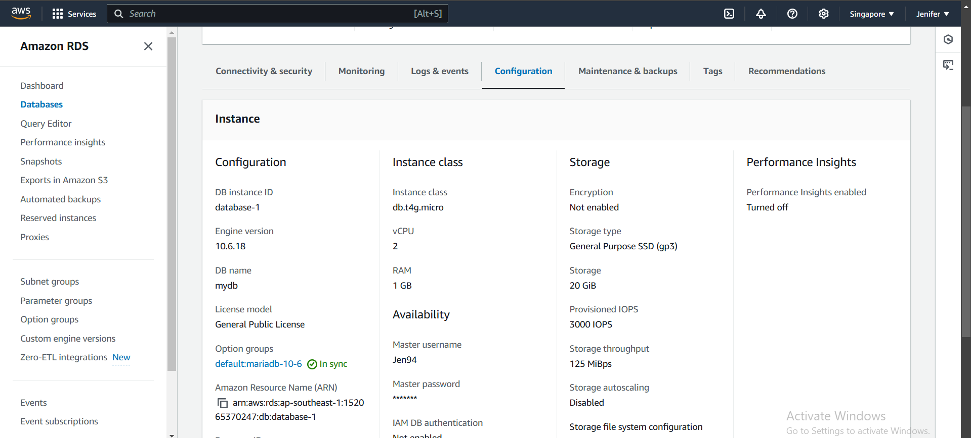

1. Logged into the Instance, Installed MariaDB & Checked the version

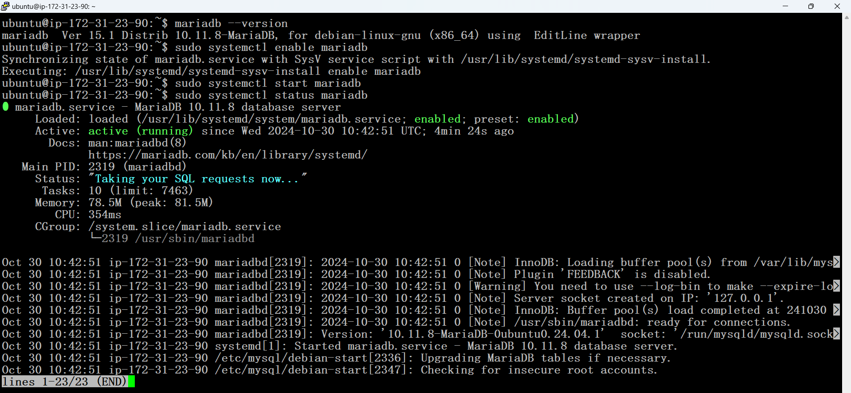

1. After viewing the status of the MariaDB, we should start MariaDB again

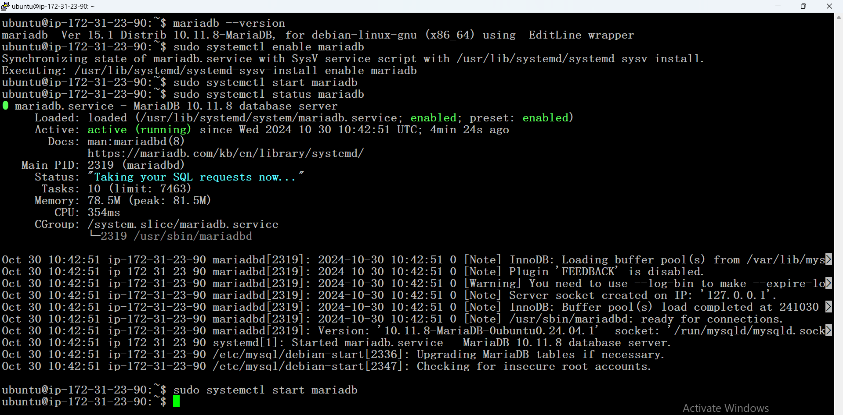

1. Endpoint Address Copied

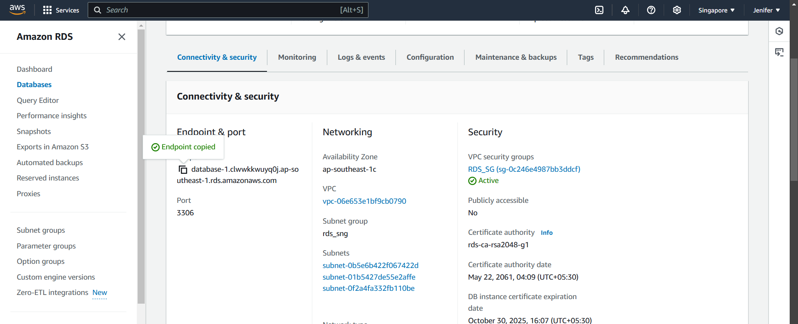

1. Using the Command “mysql -h database-1.clwwkkwuyq0j.ap-southeast-1.rds.amazonaws.com -P 3306 -u Jen94 –p “ I could integrate AWS EC2 with AWS RDS.

